**Basic WorkFlow Guide**



## **What is WORKFLOW?**

Workflow is an advanced component in Jeen.ai designed for creating automation of conversation processes and data processing using artificial intelligence in an intuitive way. Through it, you can build complex processes by simple graphic connection of different components, almost without the need to write code.

## **How does a process work in WORKFLOW?**

Input arrives that passes between components (such as Prompt, model, memory, and tools) according to the connections in the Flow. Each component processes the information and passes the output to the next one in line until obtaining the final result.

## **Creating a WORKFLOW type agent**

In order to create a WORKFLOW type agent, click on the NEW button

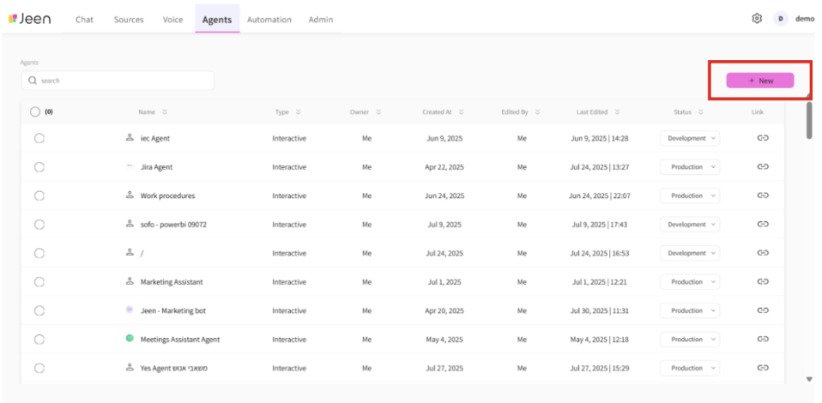

and immediately after click on the WORKFLOW AGENT button

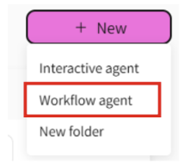

A window will open where you need to write the name of the workflow

תמונה שמכילה טקסט, צילום מסך, גופן, מספר

תוכן בינה מלאכותית גנרטיבית עשוי להיות שגוי.

After that, you need to click on the agent we created and then click on MANAGE 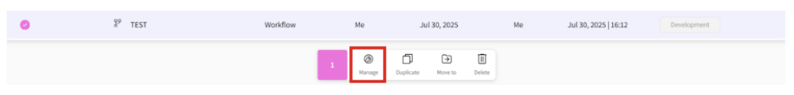

and this way we'll reach the Flow work board that we want to work on.

## **The work board consists of 3 main parts:**

1. Component list
2. Work board - to which we'll drag the components we want to work with
3. Playground - simulates the chat conversation process

## 

## 

## **Component**

In Workflow - work is performed using components - blocks that represent different operations in the process. Each component performs at least one operation: such as loading a file, processing text, sending a question to artificial intelligence, or displaying an answer in chat. Components are dragged to the work screen, connected between them according to the desired order, and thus build a process flow, without writing code.

Each component receives input, processes it, and passes the result to the next component. This is the way a WorkFlow is built, except for the components at the beginning and end of each flow that only receive input and output the result.

## **Connecting Components**

In order to create a FLOW, we connect several components that will compose the process we want to execute. The connection between components allows each component to complete its task and pass the output to the next component, so that complex operations can be performed smoothly and intuitively. The central principle in connecting components is creating a flexible system where each component performs a certain operation, and then the output of one component serves as input for the next component.

## **Connections to components:**

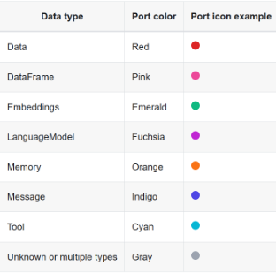

### **Basic Components**

• **Chat Input** - receives text from the user from within a chat interface. Every Flow will always open with this component.

תמונה שמכילה טקסט, צילום מסך, גופן, לבן

תוכן בינה מלאכותית גנרטיבית עשוי להיות שגוי.

• **Chat Output** - displays messages or responses to the user in chat. Every Flow will always close with this component.

תמונה שמכילה טקסט, צילום מסך, גופן, לבן

תוכן בינה מלאכותית גנרטיבית עשוי להיות שגוי.

• **Parse Data**

* Purpose - converts raw data to simple text, according to a predefined template.
* Input - JSON
* Output - text in JSON format

תמונה שמכילה טקסט, צילום מסך, גופן, מספר

תוכן בינה מלאכותית גנרטיבית עשוי להיות שגוי.

• **Prompt**

* Purpose - creates a dynamic question template with instructions and a specific question to be sent for processing.
* Input - can be anything in text format
* Output - the input influenced by the template we built

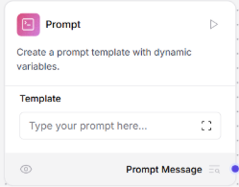

• **AGENT**

* Purpose - connection to LLM, you can choose the desired model, and add the prompt according to which the model will work. Must attach the relevant API.
* Input - text representing the user's input
* Output - text response from the LLM model

תמונה שמכילה טקסט, צילום מסך, מספר, תוכנה

תוכן בינה מלאכותית גנרטיבית עשוי להיות שגוי.

• **File** - has the ability to extract text from files.

* Input - file
* Output - simple text

תמונה שמכילה טקסט, צילום מסך, מספר, מולטימדיה

תוכן בינה מלאכותית גנרטיבית עשוי להיות שגוי.

## 

## 

## 

## 

## **Example of a FLOW that sends email through chat**

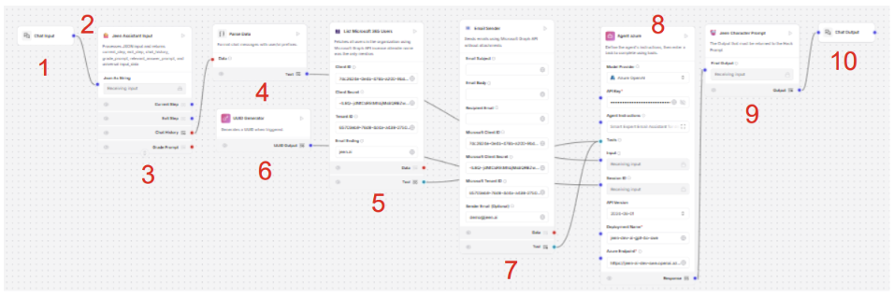

1. Chat Input component that will always open the FLOW.
2. Line stretching between components that constitutes the connection between components.
3. Component that will save chat history so that the LLM understands the context.
4. Parse Data component that converts raw data to simple text.
5. TOOL that takes all users in the organization's email and uses Microsoft.
6. Component that creates unique ID
7. TOOL through which the agent can send email
8. Component that uses a prompt with the desired LLM model and is connected to the relevant TOOLS, receives the user's input.
9. Component that creates connection with the chat in the product.
10. The component from which the output of the entire WORKFLOW will exit.